Psalm 119:105
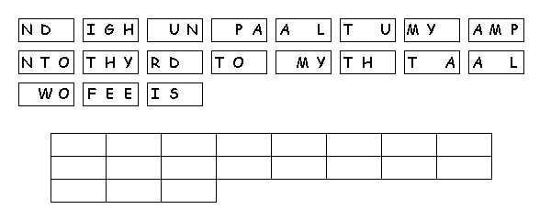
Unscramble the tiles to reveal a message.

Created by Puzzlemaker at DiscoverySchool.com

